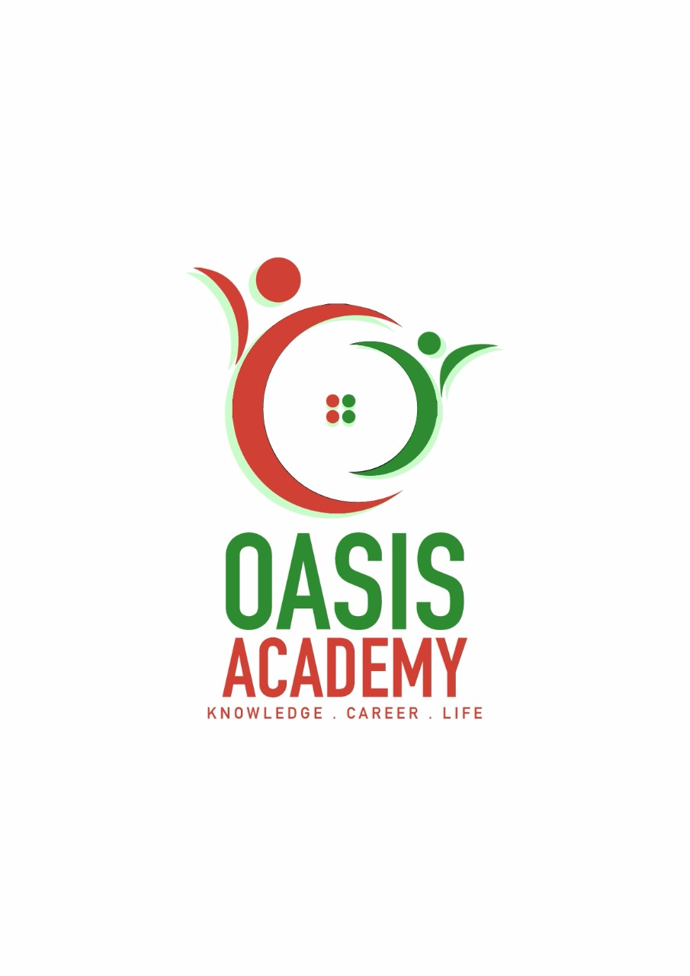

Name: Lim Ying jia

Login ID: limyingjia@oasisportal.com

Course title: Essentials of Human Resources

Subject Code: BHM01

Submitted date: 05-06-2017

**Table of Contents**

|  |  |  |
| --- | --- | --- |
| No | Details | Page |
| 1 | Executive Summary | 2 |
| 2 | Introduction | 3-4 |
| 3 | Assignment Question |  |
|  | Part 1 | 5-6 |
|  | Part 2 | 7-9 |
|  | Part 3 | 10-12 |
|  | Part 4 | 13-15 |
| 4 | Conclusion | 16 |
| 5 | References | 17 |
| 6 | Appendix | 18 |

**Executive Summary**

I studied about Human Resource Management in this module. It is about the requirements of the enterprise in the course of development and a planned rational allocation of human resource. For the first part , I learned human resource operation in hospitality management and major activities. So I will defind what my understanding in the major activities. Second part , I studied human resource planning and trends in hospitality. I covered the topic , I will explain what is my understanding on action plan human resource planning in hotel industry. Furthermore , I understanding about human resources functions and policies. So I also can describe the functions of management and how the policy applies accordingly in hospitality management. Finally , I can explain in detail about organizational behavior in hospitality and brief on groups and structure in organization.

**Introduction**

In this assignment, I learned and understand about the essentials of human resources . Human resources management mean is the process of hiring and training employees. Job analysis planning how many staff will need, training, payroll management, provide benefits, evaluate performance dispute resolution and communicating with employees. These are included in the management of human resources. Why human resource is important? Because human resource management is responsible for the entire enterprise staff management. For example Singapore is need a lot of Human Resources.

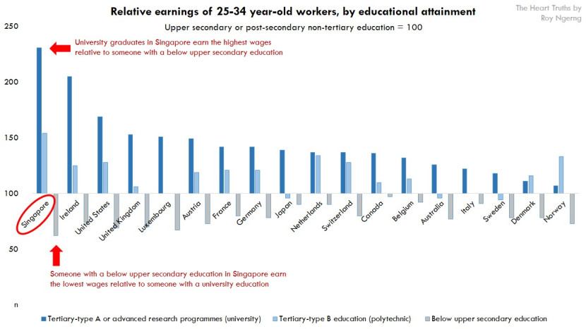

Figure 1 ( The heart truths , 2013 )

As you can see , the Singapore relative earnings of 25-34 years-old workers , by educational attainment .

**Assignment Questions**

**Question 1**

Define the Major Activities and Human Resources Operation in Hospitality Management. (20 Marks)

Answer: Human Resource Management is according to the requirements of the enterprise in the course of development and a planned rational allocation of human resources. The enterprise through the recruitment and selection, training., useful, evaluation, motivation, and others to exert employee potential and create value for the enterprise. The kinds of human resources management have macro management and micro management. Marco-management of human resources is the plan, organization and control of human resources in society as a whole to adjust and improve the human resource situation. Micro-management of human resources is through the management of people and things in the enterprise organization. Major activities of human resources management including recruiting, selecting, training, motivation, evaluation and compensation.

Recruiting

The first factor of human resources management recruiting is a process of hiring and recruit the manpower that best fit the company. Recruitment refers to the procedure of screening opplicants, analyzing the applicants talent and their possibilities to success true helping the company. In addition, recruitment including internal recruiting and external recruiting. For internal recruiting is the enterprise hiring suitable staff in company. For example recruiting is the company to hiring suitable staff from outside. For example, the company to published a recruitment advertising or the company can through the employment agencies get the suitable staff.

Selecting

Selecting means is the company from the information relevant to the work of the candidates resume and understand candidates previous work experience, educational background and deciding whether to interview candidates. And the company through the candidates knowledge, skills, abilities, personal style and attitude and deciding whether to select candidates.

Training

The company will provide vocational training for employees in oder to realize the company's development goal. The enterprise training staff has two of ways. The two of ways is induction training and on-the-job training. Induction training is provide training for the new staff to familiarize them with specific work. And the second ways is on-the-job training means is provide training for existing staff to update their knowledge and skills.

Evaluation

Evaluation means is evaluation of employees' performance by enterprise and to ensure that the objectives of the enterprise are met. Apart from this, the enterprise evaluation who are performance well and who aren't. If employees performance well will get some extra rewards. If the work performance is not good will be punished.

Compensation

Compensation refers to the payment of time, knowledge and skill paid by the enterprise to the employees. In addition, company offer additional benefits such as stock options employees. For examples, if employees buy something in the company will get the 50% discount.

**Question 2**

Describe in brief on Human Resources Planning and Planning Trend in Hospitality.

Explain about what is your understanding on Action Plan Human Resource Planning in Hotel Industry. (20 Marks)

Answer: Human Resources planning means how to configuring the right person at the right time to do right job. It's to enhance the business performance of enterprises and provide suitable manpower for the development of enterprises. According to the organization's development strategy, objectives and changes in the internal and external environment and forecasting the human resources demand and supply of human resources.

Human resources planning trend

First , graduate intake program. Human resources can be open to students in internships. Such as, work plus study. Second talent pool. The company can creating database by using information technology or mini recruitments agency and let the company more famous. The company continue to introduce talent to help the company continue to develop and innovation . Moreover, E-recruitment. Recruitment staff for design website, receiving CVs from E-mail. At the same time, the company must recruitment of right type of people because it will be related to some of the company's business processes . Furthermore, effective human resources planning. Human resources planning must conform to the overall objectives of the enterprise. At the same time, it must be supported by senior management to implement. The overall work must be coordinated with the management staff. At the last, limitations of human resources planning. Human resources professional face three problem in preparing for management of human resources plans.First, accuracy. Second low level management support. Third is lopsided focus on quantitative aspects. These will affect the implementation of the human resources plan.

Accessing Human Resources

The first step access human resources is using quantitative analysis of human resources of human resources is to check whether the number of existing employees conforms to the standard of an institution in a certain amount of business. Apart from that, the analysis of personal category also can help in accessing human resources includes two kinds of analysis. First, work function analysis. There is a lot of work ability of employees in an institution including the business personel technical staff, production staff and management staff. They can examine the structure of products or markets and how the methods and skills to supply the labor market. Second, analysis of the characteristic of work. It aims at ascertaining the HR needs of the organization, in right number and in right kind and balance on their own working conditions and relationship in which they work. In order to getting better quality of the staff. At first a company should analysis the job content in order to find a suitable individual to handle to job, so that the work task can be handle more wisely . Second. Training to enhance the ability of serving existing staff . Third, temporary adjustment may be made if an employee has retired or has a rotation or a change in hospitality management. Fourth whether the transfer of an employee will affects the organization moral, and makes employee lose their sense of security and deteriemental to the stability of the organization . Next , if can't find the ideal replacement of the appropriate candidates from the inside or outside in the short term, you should take mitigation measures to avoid even greater losses .

A) Age structure analysis

Analyze employees age structure, statistics on the age distribution of staff in the company. First whether the organization I younger. On the other hand, the ability of organization to absorb new knowledge and new technologies . Next, the physical load of the organization work ideal age allocation for employees in enterprises is 50 years old is senior age staff. Middle age staff will be in between 35 and 50 year old and the younger age staff is 20 to 35 years old .

B) Position structure analysis

Analysis the position of their supervisor and non-supervisor in manpower structure if there are too many position in an organization it is makes a lot of problem, first unreasonable organizational structure and too many departments and levels . Furthermore, complex working procedures its make wasting time to communicate and coordinate . Moreover, low productivity .

Demand forecasting

Demand forecasting is the practice of evaluating the future quality of employee required and the company may examine the market need what kind of the characteristic of people and how many employee just enough. For example, the counter department just need 2 people instead of 4. Both of them can communicating in English very well. Besides the company must be established a good salary and benefit for employee to motivate employees to active working with the enterprise and retain talent . For example ,the company content the basic needs of employees because employees could feel relieved to work . Finally, the company provide the safety and health environment for employee .

Supply forecasting

For supply forecasting of human resources the company need to consider internal and external supply from internal supply. The company have to get a suitable position for the candidates . Moreover, it works as an employees is recommended. External supply side, the company to hire suitable staff from outside. The way should go through an employment institute to get the suitable staff .

Matching demand and supply

The company through the demand and supply forecasting can get the problem of the shortage or excess of employee at a certain time.

Assessing Human Resources



Demand Forecasting



Supply Forecasting



Matching Demand and Supply



Action Plan Human Resources In Hotel Industry

**Question 3**

Brief about Human Resources Functions and Human Resources Policies.

Describe the Functions of Management and How the policy applies accordingly in Hospitality Management. (20 Marks)

Answer :

Human Resources Function

Compensation and benefits

Compensation and benefits should be like labour relations. On the compensation side setting the compensation relations. On the compensation sides, the compensation structure and assessment of competitive remuneration practices including human resources functions .

For the compensation structure example, compensation structure is simple and clear so that employees can understand calculations. In addition, the employee insurance , bonus , employee travel, retirement pay also is company to pay compensation other than staff salaries .

Safety

The safety of the workplace is very important factor, the enterprise staff training in order to improve productivity but it's not enough. The enterprise must to create a safe and healthy environment for employees. Its make the environment safety and comfortable and colleagues to maintain a healthy competition .

Employees Relation

Labour relation means is autority and obligations between employee and employer. Its including interview . Compensation benefits, training , safety and health, retirement and collective bargaining between employees and employers on compensation and working conditions. In order to get along with each other, our country has setting relevant decrees to stop the employer from bullying the welfare of the labour . At the same time, it will also protect the management from the threat of labour, equal and open communication are one of the important ways to labour problems or conflicts. The human resources department of the enterprise is responsible for building a communication bridge for both employers and employees. It's help to retain employees and improve employee productivity and commitment .

Compliance

Compliance with labour and employment laws is a critical human resources function. Non compliance can result in workplace compliance Such as, unfair employment practice and discrimination . Next, employment dissatisfied with working conditions that can affect productivity. Human resources staff must be aware of federal. Besides that, compensating employees must adhere to be existing legislation in the areas of labour standards, pay equally. Human rights and so on . Regularly, reviewing the human resources toolkit , key government websites, and connecting with an legal professional can help you ensure that your organization's compensation practice with current legislation in your jurisdiction. At the same moment, issues may include but not limited, wages, leave options, termination pay and more. Auditing your compliance with legislation annually is time consuming yet critical to the sustainability of your organization.

Training development

Employers must provide training and development for employees in order to improve staff skills and quality . At the same time, it's try to help the development and management of the enterprise. For employees , development potential through training to better career. Such as a college degree. For example, tuition assistance and tuition reimbursement programs often within the preview of the human resources training and development area .

Human Resources Policy

Human resources policy principles and rules is a member of organization must be followed. Each policy involves important questions of the organization mission and operations. Good human resources policy provides extensive guidance on the method used by the organization and providing general guidance on employment for employees . First, organization structure in a company that have set the organizational structure of the entire company, this is the company policy . For example, the organization has a chairman. A manager, two secretaries . This is the organization human resources policy so everyone must follow this organizational structure . Moreover , ensure long term benefits of employees. Such as, employees enjoy monthly rent subsioly . This is the policy formulated by the company human resources department. Better policy ensures uniform, consistent treatment of all employees throughout the organization . Next, is to ensure that the most expeditious action is taken in the policy can prevent waste of time and energy from repeatedly analyzing to solve similar problems .

Such as, front office operation in hotel . The front office is the coe of the hotel. The front offices functions include reservations, check in and check out, guest and concierge services and accounting department. Standard operating procedures for hotel front office is a guide to maintaning a sufficient level of revenue and services consistency in the hotel front office . The booking process at the front office is to collect customer information and generate good revenue . At the same time, front office employee should perform a warm and friendly way to collect customer information. In addition, the front office employee is responsible for handling the customer check in procedures and arranging room service employee to assist with moving the baggage and escort the customer to their room. The front office employee also responsible customer check out procedures. The front office provide handling baggage assistance . Furthermore, the concierge will always provide efficient, friendly and coordinated assistance to guests. Such as, restaurant reservation, solve safety problems, hire limousine transportation , etc . All above are the things that front office should be operate in hotel .

**Question 4**

Explain in detail about Organizational Behavior in Hospitality and brief on Groups and Structure in Organization. (20 Marks)

Organizational behavior in hospitality is to study how people interact in groups. This research area examines human behavior in a working area and works on its structure performance , motivation , communication etc . Next, in a group of people to be an organization, they need to communicate and coordinate their activities. The more effective the communication the more efficient the activity done .

Psychology

Psychology is a scientific study of human, animal psychological function and behavior. Organization psychological study workplace relationships, attitudes and behavior. The goal is to promote employee satisfaction with their jobs and mental health of their employees to help the company

Sociology

Sociology is the scientific study of the nature and development of society and social behavior. The analysis of organization sociologists is mainly to better understanding of group dynamics , work , norms , roles , status , organizational culture and so on .

Anthropology

Anthropology is the study of society to learn about human beings and their activities. Anthropology is mainly about analyzing comperative attitudes and comparing values which influence organization environment and culture .

Political Science

Political Science focuses on the behavior of individuals and groups in a particular political environment. Political science has made great contributions to organizational conflict, power distributions and the overall administrative process within the organization .

Communicating

A) Hierarchy

Communication between management and labour is important. The greater the impact of the company, the more complex organizational structure. In a company, everyone needs to know who they are reporting to and who they are managing. When these roles and communication methods are not clear, it will result in low effiency and lower profit .

B) Cooperation

The smooth operation of the work depends on the cooperation between colleagues. In order to cooperate with good colleagues need effective communication .

C)Feedback

Solicit feedback from staff and improve can increase efficiency and productivity

Motivating

Motivating employees to complete their work on time is one of the main tasks of management in a company. One of the effective ways to change the employees position in the company

A) Social Perception

Social perception or personal view of others affect behavior in the organization. For example, if a person mistakenly considers another person character to be the cause of a negative event and procedures a wrong social cognition, it may lead to an organizational behavior problems .

B)Perceptions Affecting Motivation

Employees social perceptions of other people in the organization may affect his motivation to work efficiently if a staff member feels the opportunity to carry out personal development or professional progress, if he is able to complete the task correctly and participate in various organizational decision making and goal setting processes , the motivation is still high . If employees feel the lack of the opportunity to improve . The motivation will be reduces

Mentoring

The fundamental component of a successful business is embedding strong mentoring plans into organizational behavior. When a employees in an organization encounters a big problem, a mentor is needed to guide and solve the problems. Experienced mentors can help managers solve these problems to improve organizational behavior and strengthen the organization process. Mentors can help organize administrations by analyzing their career development. At the same time. Through learning to promote career development, administration can better the project authorization .

Trust Buidling

The issues of trust in the workplace can break or destroy organization culture. Distrust means that productivity is severely limited. Trust in the organization is difficult to define and measure. Trust is the main leadership of the enstablishment and maintenance work in their organization. Improve efficiently will increase the speed of trust among colleagues if in little in work environment will result in reduced efficiency between colleagues .

Listening

In an organization listening can reduce conflicts. When individual employees feel misunderstood or adused might cause conflict. Such as if you fail to listen the instruction your colleagues need to help you complete tasks you should perform . Next, your colleague might be unhappy with you listen is important in the operations of the organization. Good listener can make the whole organization more efficient .

Definition of the organizational structure of how the task allocation. Coordination and supervision enables organizations to achieve strategic objectives. Organizational structure will determine, its made of operation and implementation. Organizational structure to assign responsibility for different functions and processes to different places such as department , branch , individual and workgroup .

**Conclusion**

In this assignment, I learned about human resources management. The first step, I learned five major activities of human resources management. The five major activities is very important because related to the operation of the entire company. That is the recruitment staff by advertise, selecting right type of people, staff training, evaluation for staff performance, and compensation. And the second part, I learned human resources planning. Human resources planning is how to configuring the right person at the right time to do the right job. The functions of human resources is employee relation, compliance and some benefits for employer and employee. And the human resources policy is the employee must comply with the policy of the whole company. Such as long-term free for rent. And the last, organizational behavior is important of management in a organization. Such as manager responsible supervise staff. Make the whole organization more efficient . Finally, human resources management is very important for a enterprise .

**References**

(Information from another source must be credited in the reference page)

1. The heart truths ( 2013 ) ( online ) SINGAPORE category education.

Retrived From : <https://thehearttruths.com/category/education/>

2. The heart truths ( 2013 ) ( online ) SINGAPORE category education.

Retrieved From : <https://thehearttruths.com/category/education/>

3. Introduction to human resource management in hospitality industry ( 2015 ) ( online )

Retrieved From : [https://www.slideshare.net/CrystialParrilla/introduction-to-human-resource- management-in-hospitality-industry](https://www.slideshare.net/CrystialParrilla/introduction-to-human-resource-      management-in-hospitality-industry)

4. Human Resources policies of hotels ( 2014 ) ( online )

Retrieved From : [https://www.slideshare.net/SomitraUpadhyay/hr-policies-of-fortune- landmark-hotel-and](https://www.slideshare.net/SomitraUpadhyay/hr-policies-of-fortune-                   landmark-hotel-and)

5. Chapter one Organizational Behavior ( 2014 ) ( online )

Retrieved From : <https://pt.slideshare.net/rajasshrie1/chapter-1-ob-38248150/12>

**Appendix**

(Appendix is for more detailed information on a subject that is too long to explain in 1 page)

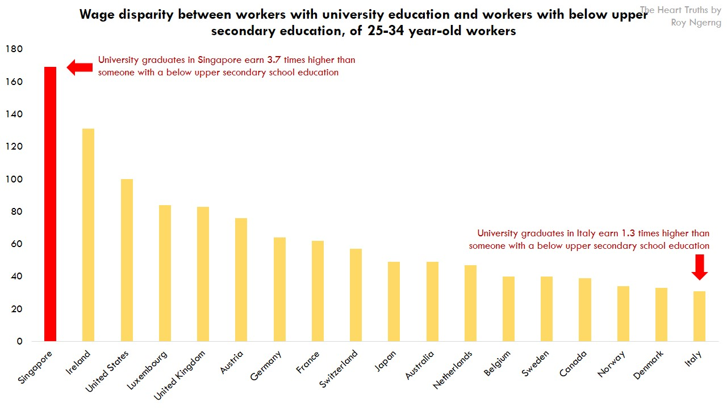

Figure 2 ( The heart truths , 2013 )